EVALUATION OF ELI PROJECTS UNDER THE TURKISH LAW  WEBINAR SERIES | 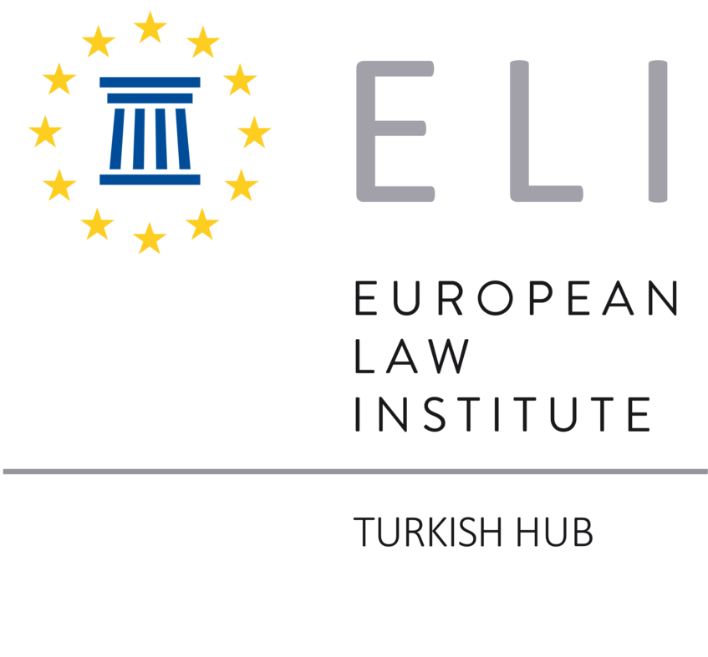

European Law Institute (ELI) aims to stimulate the development of EU law, legal policy, and practice through various projects. These projects also have the potential to influence Turkish law. To ensure that Turkish lawyers are familiar with these projects, ELI Turkish Hub translated them into Turkish and also organizes a series of webinars in Turkish where these projects and their potential influence in Turkish Law will be discussed. The first three webinars will be held online on the dates below. The webinars are open to anyone who is interested in these topics.

Tuesday, 16 May 2023, 17:00-18:30 TR

ELI Draft of a Revised Product Liability Directive

Moderator: Başak Başoğlu
Presentation of the Project: Beril Kaptan
Discussions under Turkish Law: Samim Ünan
Şebnem Akipek
Ceyda Süral Efeçınar
Link to join the webinar.

Thursday, 8 June 2023, 17:00-18:30 TR

ELI Principles on Blockchain Technology, Smart Contracts and Consumer Protection

Moderator: Kadir Berk Kapancı
Presentation of the Project: Nesli Şen Özçelik
Discussions under Turkish Law: Pınar Çağlayan Aksoy
Ekin Ömeroğlu
Link to join the webinar.

Thursday, 6 July 2023, 17:00-18:30 TR

Model Rules on Online Platforms

Moderator: Ayşegül Buğra
Presentation of the Project: Doğan Yörük
Discussions under Turkish Law: Eylem Aksoy Retornaz
Kadir Berk Kapancı
Link to join the webinar.

